|  |
| --- |
| **NUCL 355 Experiment 10** |
| Transient Heat Conduction  Professor M. Bertandano |
|  |
| School of Nuclear Engineering  Purdue University  Report of the Experiment By:  Weston Cundiff, Stephen Cox, Kara Luitjohan, Patrick Burk, Dominic Ghering, Michael Stryker, Austin Curtis, Matt Metzger, et. Al. |
| **Written By Alex Hagen** |
| **4/5/2011** |
|  |

# Introduction and Theory

The lumped capacitance method is an easy and useful method for analyzing the heating and cooling of elements. It hinges upon a central criterion that must be met before the method can be used accurately. This criteria is that the Biot number must be much less than one (generally under 0.1), as shown below.

$$Bi=\frac{hL}{k}≪1$$

With this criteria met, several assumptions can be made. First, the assumption that radiation is negligible has to be correct for the system. The next assumption is made from the Biot number criteria shown above. This assumption is that conduction occurs must “faster” than convection (i.e. that k>>h). If conduction occurs must faster than convection, then the limiting factor for the cooling of the material is the convection of heat off the surface. With these assumptions, and no heat generation in the system, the only important heat terms are the change in heat from convection and the stored heat. An energy balance with only these two looks like the following equation:

$${\dot{E}}_{conv}={\dot{E}}_{st}$$

Substituting physical quantities in, the differential equation becomes:

$$hA\left(T-T_{∞}\right)=ρVc_{p}\frac{dT}{dt}$$

In order to generalize this method for any material, a parameter of relative temperature must be used. If absolute temperature were used, the math would show cases where a material could cool past the surrounding, which is physically impossible. Another physical constraint put on the system is that the surrounding temperature must be approximated as constant. The relative temperature parameter is as follows:

$$θ=T-T_{∞}$$

Plugging this parameter into the differential equation and using separation of variables:

$$hA\int_{0}^{t}{dt}=ρVc_{p} \int_{θ_{i}}^{θ}{\frac{dθ}{θ}}$$

$$T-T_{∞}=(T_{i}-T_{∞}) e^{-\frac{t}{τ}}$$

The equation above is a very common form that is often used in electronics. In electronics, it is for a first order resistor-capacitor circuit. This means that the capacitor is charged up to a certain point, and then the resistor decays that electric charge off. This is a good interpretation of what occurs in the lumped capacitance method. In this experiment, the slab is “charged” with heat up to a certain point, and then the convection decays off that heat over time. Because it can be modeled as a circuit, the time constant, $τ=RC$ can be used. Because the resistance is analogous to convection and capacitance analogous to the stored energy, the time constant becomes:

$$τ=\left(\frac{1}{hA}\right)\left(ρVc\right)$$

Using the method of lumped capacitance, the exponential decay of temperature of the slab in this experiment will be easy. The time values and temperature values will be taken, and then the cooling curve analyzed to show the lumped capacitance validity.

# Analysis and Discussion of Data

Three trials were done in this experiment, two different analyses on an Aluminum slab, and one on a Stainless Steel slab. Each trial included two thermocouples, which took data at a small time interval for the time range of 10 minutes. These time values were plotted against corrected values for temperature in each of the trials. A correct value for temperature was found by taking the value from the thermocouple. If the value was -9999 deg C, or if the value was larger than the previous value, then the value was replaced with the previous value. Heating was impossible, as was the value -9999 deg C, so those must be inaccurate data recorded by the thermocouple. By using the previous value, some inaccuracies were created, but the incorrect values recorded by the thermocouple were more apparent when charted. The three trials are shown in the charts below:

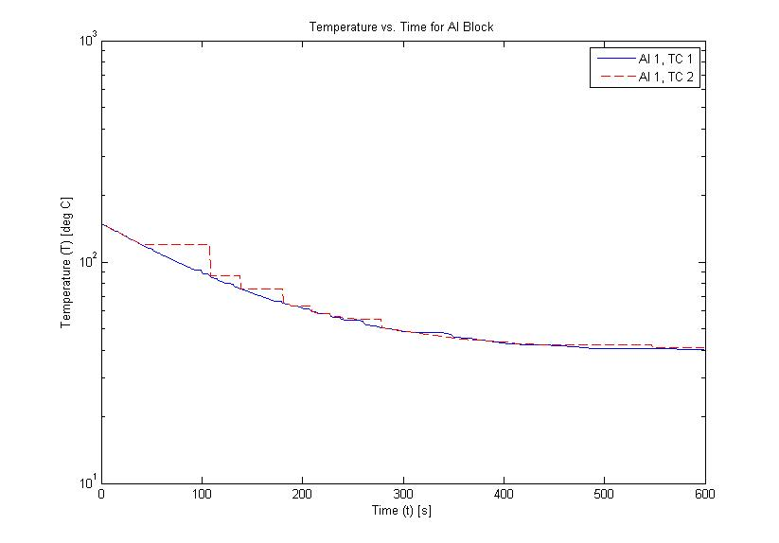

Figure .1 Aluminum Cooling Curve 1

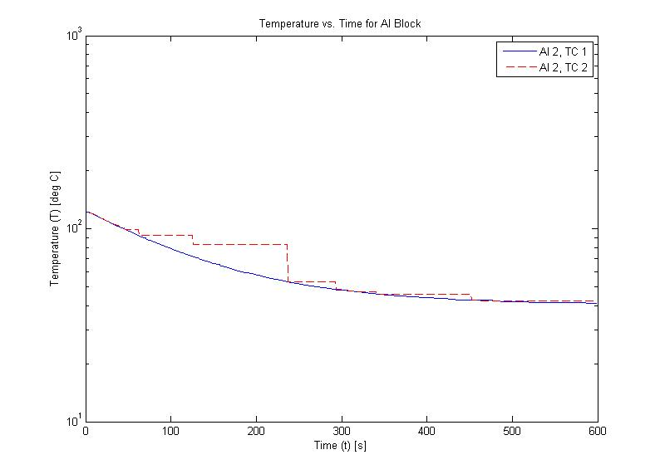

Figure .2 Aluminum Cooling Curve 2

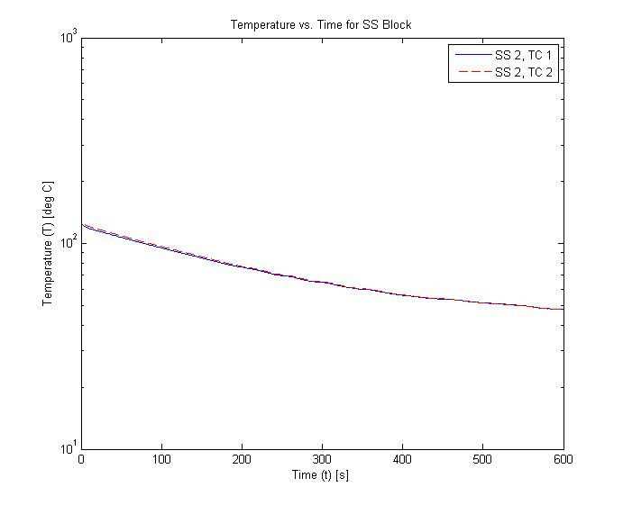

Figure .3 Stainless Steel Cooling Curve

As shown in the curves, some of the trials were vastly inaccurate. In particular, the second thermocouple picked up many incorrect values in the aluminum trials. Because of this, all values recorded by the second thermocouple were thrown out, because it was not able to be trusted. Its placement in the block may have had something to do with this problem.

Using the three trials, only thermocouple one, fitting was done using MatLab software. The fitting done used the relative temperature parameter ($θ$) against the time values. This chart was fitted with an exponential decay type fit, with the form $y=a e^{bx}$. The translation from this into lumped capacitance is shown in sample calculations. Using these fitted parameters, the heat transfer coefficient and the time constant can be calculated, and are shown (along with pertinent values) in the table below:

|  |  |  |  |  |  |  |  |
| --- | --- | --- | --- | --- | --- | --- | --- |
| Data Set | b | tau | Theta_i | R^2 | u_tau | h | u_h |
| Al 1 | -0.0084 | 119.59 | 110.7 | 0.9987 | 0.0013 | 518.41 | 0.0065 |
| Al 2 | -0.0085 | 117.90 | 83.97 | 0.998 | 0.002 | 525.85 | 0.017 |
| SS 1 | -0.0051 | 195.27 | 77.83 | 0.9946 | 0.0054 | 112.40 | 0.019 |

Table .1 Heat Transfer Coefficients

These values tend to agree with the general trend expected. Both aluminum trials are similar in value, and the stainless steel value is much smaller, as expected. As a second way to check the validity of the model, the Biot number must be checked. This value should be much less than one, and can be calculated using the thermal conductivity values from literature as well as the calculated heat transfer coefficient above.

$$Bi=\frac{hL}{k}$$

|  |  |  |
| --- | --- | --- |
| Data Set | Bi | u_Bi |
| Al 1 | 0.056033 | 7.11E-07 |
| Al 2 | 0.056837 | 1.90E-06 |
| SS 1 | 0.175154 | 3.05E-05 |

Figure .4 Biot Numbers

The Biot numbers are generally well below 1, which is what the criteria is. This shows that in these cases, the lumped capacitance model is a valid model to use. The small error values are also encouraging in this analysis. A sample plot of the relative temperature against time is shown below, with the lumped capacitance model overlaid. It is obvious from this chart that the lumped capacitance provides a good estimated through the range needed.

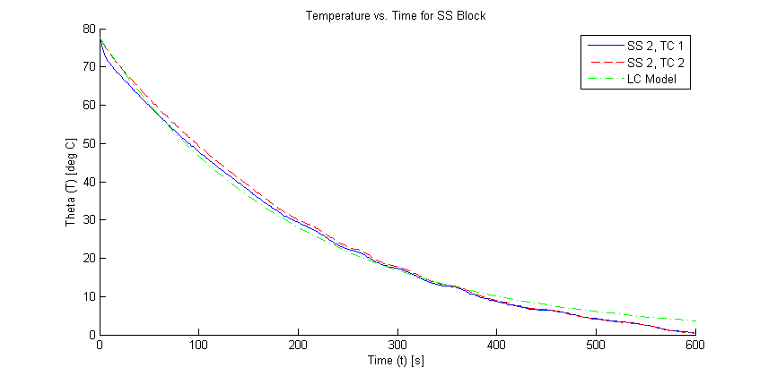

Figure .5 Theta (T-T_inf) vs. Time for SS Block

## Error

Besides the bias error on the instruments, the error in this experiment comes from the fit of the line to the data. This error is given in an R^2 value, and is generally very high (showing good fit). Error propagation has been done throughout the calculations in sample calculations and shown as uncertainty in the tables. Bias error was not shown on the charts because it is so small for the accurate thermocouples that the error bars would simply thicken the line, blurring the correlation of data.

## Recommendations

This lab provided very good data and was generally ran very efficiently. The only glitches that occurred in this experiment were the problems with the thermocouple, and the fact that the surrounding air wasn’t perfectly constant in temperature. If possible, thermocouples that will not short should be used, as well as a higher air flow rate to make the air temperature more constant. Other than these two problems, the experiment ran very smoothly.

# Conclusions

Through this experiment, a good explanation of the use of lumped capacitance method was provided. The experiment was performed by using two different large blocks of metal (stainless steel and aluminum). They were heated separately, then suspended in a chamber through which air was blown. This provided a constant temperature environment. Readings were taken from two thermocouples within the slabs, and one in the surrounding environment. The curve was taken as these slabs cooled for ten minutes.

Because Biot numbers of .056, .057 for aluminum and .175 for stainless steel were found, these fit the criteria that must be met for the use of the Lumped Capacitance method. The lumped capacitance method allowed for the data to be analyzed as the relative temperature over time. This relative temperature is the temperature within the block minus the ambient temperature. For the use of the lumped capacitance method, the ambient temperature must be assumed constant.

Another correction of data was done for faulty readings from the thermocouples. At a small amount of points in each trail, the temperature was found to rise or to be -9999 deg C. These are physically impossible, so they were removed and assumed to be a value from the data set to minimize error.

Upon the use of the lumped capacitance method, the exponential decay was found for each of the three trials, with parameters of the time constant (a combination of convection and energy storage) and the initial theta. The r^2 values found for the model were 0.9987 and 0.9980 for aluminum and 0.9946 for stainless steel, showing very good correlations.

Through the time constant, the heat transfer coefficient could be calculated with minimal error. The heat transfer coefficients were found and seem physically accurate. The aluminum trials provided the coefficients 518.41 and 525.85 W/m^2 K. The stainless steel trial provided the value 112.40 W/m^2 K. These seem to be accurate because of the properties of these metals. Aluminum has a much higher conductivity, thus can get rid of the heat from the surface much quicker than the relatively slow moving heat within the stainless steel.

# Works Cited

Munson, Y. O. (2009). *Fundamentals of Fluid Mechanics.* Hoboken, NJ: Wiley and Sons, Inc.

Revankar, S. (2011). *Experiment #10: Transient Heat Conduction.* West Lafayette, IN: Purdue University School of Nuclear Engineering.

Wolfram Alpha LLC. (2011). *Wolfram|Alpha: Computational Knowledge Engine*. Retrieved 2011, from Wolfram Alpha: http://www.wolframalpha.com

# Appendices

## Original Data

The amount of original data collected makes it inappropriate to include in this report. If data is needed for closer analysis, please email Alex Hagen at [ahagen@purdue.edu](mailto:ahagen@purdue.edu) to obtain a copy.

## Reduced Data

|  |  |  |  |  |  |  |  |
| --- | --- | --- | --- | --- | --- | --- | --- |
| Data Set | b | tau | Theta_i | R^2 | u_tau | h | u_h |
| Al 1 | -0.0084 | 119.59 | 110.7 | 0.9987 | 0.0013 | 518.4132 | 0.006577 |
| Al 2 | -0.0085 | 117.90 | 83.97 | 0.998 | 0.002 | 525.8528 | 0.017585 |
| SS 1 | -0.0051 | 195.27 | 77.83 | 0.9946 | 0.0054 | 112.4021 | 0.019567 |

Figure .1 Heat Transfer Coefficients

|  |  |  |
| --- | --- | --- |
| Data Set | Bi | u_Bi |
| Al 1 | 0.056033 | 7.11E-07 |
| Al 2 | 0.056837 | 1.90E-06 |
| SS 1 | 0.175154 | 3.05E-05 |

Figure .2 Biot Numbers

## Sample Calculations

### Data Correction

For the data taken from the thermocouples, heating is not possible, and neither is a value of -9999 (which was recorded at many points). These points were deemed inaccurate and taken out of the data set, replaced with the previous legitimate reading. Although this does not reduce the error completely, it will reduce the error a fair amount.

### Time Constant

Data analysis was done using the curve fitting tool in MatLab. This gave an equation of the form $y=a e^(bx)$. To fit this equation to the equation for lumped capacitance, the coefficients were taken to fit the form $T-T_{∞}=(T_{i}-T_{∞}) e^{-\frac{t}{τ}}$. This definition provides $τ=-\frac{1}{b}$ and $a=θ_{i}=T_{i}-T_{∞}$. Sample Curve Fitting:

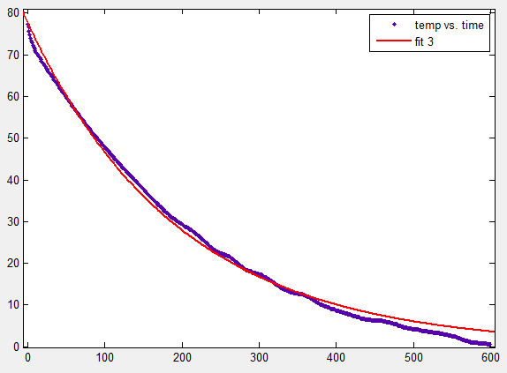

### Time Constant Error

The R^2 value gives the goodness of fit, which can be converted to error by simply: $u_{τ}=1-R^{2}$

### Heat Transfer Coefficient

$$τ=\left(\frac{1}{hA}\right)\left(ρVc\right)$$

$$h=\left(\frac{ρVc}{τA}\right)=\left(\frac{ρ_{ss}l_{thickness}c_{p,ss}}{τ_{ss}}\right)$$

$$h=\frac{\left(7863\frac{kg}{m^{3}}\right)\left(0.0254 m\right)\left(109.9\frac{J}{kgK}\right)}{195.27}$$

### Heat Transfer Coefficient Error

$$u_{h}=\frac{∂h}{∂τ}u_{τ}=\frac{ρVc_{p}}{Aτ^{2} }u_{τ}$$

### Biot Number

$$Bi=\frac{hL}{k}=\frac{\left(112.40\frac{J}{m^{2}K}\right)\left(0.0254 m\right)}{16.3\frac{W}{mK}}=0.18≪1$$

### Biot Number Error

$$u_{Bi}=\frac{∂Bi}{∂h}u_{h}=\frac{L}{k}u_{h}$$